roid

217, Sheikh Rashid Building

P.O Box 56272, Dubai

United Arab Emirates

Tel: +971 4 2973236 / 04 2974007

Email: uae@verbat.com

PROJECT   
PROPOSAL

**ADSC**

|  |  |
| --- | --- |
| **Prepared for:**  **Ahmed Obaid Al Tunaiji** | **Submission Date:**  22 May 2017  **Proposal ID:** AD/BP/22052017/1343/1 |

___________________________________________________________________________________________________________________________________________  
Conﬁdentiality Notice: This Proposal is conﬁdential and contains proprietary information and intellectual property of Verbanet Technologies LLC. Neither this proposal nor any of the information contained herein may be reproduced or disclosed under any circumstances without the express written permission of Verbanet.

© 2017 by Verbanet Technologies LLC. All rights reserved. Confidential.

___________________________________________________________________________________________________________________________________________

Project Contacts

|  |  |
| --- | --- |
| Client Information | |
| Project Name | Licensing and Classification System |
| Client Name | Sharjah Commerce and Tourism Development Authority |
| Client Address | Buheira Corniche Road - Sharjah - United Arab Emirates |
| Contact Person | Mr. Ahmed Obaid Al Tunaiji |
| Contact Person Email | Ahmed.ot@Sharjahtourism.ae |
| Contact Person Phone Number | 9 716 519 0961 |
| Verbat Information | |
| Contact Person | Joyce Daniel |
| Contact Person Phone Number | +971 42973236 |
| Contact Person E-Mail | [joyce.daniel@verbat.com](mailto:joyce.daniel@verbat.com) |
| Address | PO Box 56272, Dubai, United Arab Emirates |
| Physical Address | 217, Sheikh Rasheed Building, Hor Al Anz East |
| Project Information | |
| Proposed Technology/Methodology | AngularJS, NodeJS, ExpressJS, MongoDB |
| Anticipate Start Date | NA |
| Proposal Valid For | 30 Calendar days from the submission of the proposal |

**Table of Content**

1 Intoroduction 7

1.1 Background 7

1.2 Overview of Tourism Standard Department (TSD) 7

1.3 Objectives of Licensing and Classification Services (LCS) 8

2 Scope 8

2.1 Key Platform Stakeholders / “Actors” 9

2.2 Proposed Solution Model 11

2.3 Solution Objective 11

2.3.1 Primary Approval for trade license for new hotel 14

2.3.2 Approval for modification of building plan 15

2.3.3 Primary Approval for Trade License Renewal 17

2.3.4 Approval for Trade Name 18

2.3.12 Approval for Hotel Name Change 19

2.3.13 Issuance of Primary Approval for Hotel/Hotel Apartment Operation Resumption 21

2.3.14 Issuance of Primary approval for Trade License Cancellation of the Hotel/Hotel Apartment 22

2.3.15 Approval for hotel Management License 23

2.3.16 Approval for Tour Operator License 24

2.3.22 Approval for New Tour Guide License 25

2.3.24 Reprinting/Replacement of Issued Tour guide License Card 26

2.3.25 Fine Issuance and Collection/Payment 27

2.3.26 Toursim Inspection and Classification Services 28

1.3.26.1 Hotel/Hotel Apartment Inspection 28

2.3.27 Languages 32

2.4 Advantages of Proposed Solution 32

2.5 Why Verbat 33

2.6 Key Differentiators 34

2.7 Technology & Services 35

3 Functional Specification 36

4 High Level Design 40

4.1 Use case Diagrams 40

4.2 Data Flow Diagram 42

4.3 Workflows 43

4.4 Generic Workflow 44

4.5 Functional Architecture 45

4.6 Application Level features 46

4.7 System Level Features 47

4.8 High Level Architecture 49

5 Nonfunctional Requirement (Others) 51

6 Assumptions 51

7 Out of Scope 52

8 Technology Solution 53

8.1 Proposed System Environment 53

8.2 Technical Configurations 54

8.2.1 Development Tools 54

8.2.2 Recommended Web Hosting Package 54

8.2.3 Browser Compatibility 54

8.2.4 Hardware Interface 54

9 Commercials 55

9.1 Web Application 55

9.2 Payment Terms 55

9.3 Mode of Payment 55

10 Delivery Management 56

10.1 Project Management 56

10.2 Roles and Responsibilities 56

10.3 Delivery Activity Summary 58

10.4 Project Implementation Plan 58

10.5 Deliverables 59

10.6 Estimated Delivery Time 59

10.7 Deployment Details (at Clients Behest) 61

10.8 Release Planning 61

10.9 Risk and Contingency Planning 61

11 Change Management 62

12 Miscellaneous 64

12.1 Acceptance Criteria 64

12.2 General Terms and Conditions 64

12.3 Assumptions and Dependencies 65

12.4 Source Code & Intellectual Property Rights 66

12.5 Maintenance & Support 66

12.6 Service Level Agreement 67

13 Our Clients 68

# Introduction

## Background

Abu Dhabi Sports Council (ADSC) was established in 2006 by His Highness Sheikh Mohamed Bin Zayed Al Nahyan, Abu Dhabi Crown Prince and Deputy Supreme Commander of the UAE Armed Forces. The Council promotes an effective, emirate-wide sports calendar that stimulates the desire to participate in quality sports among all Abu Dhabi residents and helps the talented and motivated reach their sporting potential. The Council also hosts and supports the staging of international world-class sporting events, including the annual Abu Dhabi HSBC Golf Championship, the Formula 1TM Etihad Airways Abu Dhabi Grand Prix, the ITU World Triathlon Series, the Abu Dhabi Invitational, the Gary Player Invitational, the FIBA 3x3 World Tour Final, the Red Bull Air Race, the hosting of the Volvo Ocean Race round-the-world sailing epic, the Abu Dhabi Cycling Tour and the 2015 Nomura Cup.

Abu Dhabi Sport Counsel (Here after referred to as the client) has requested Verbat to create a proposal that will automate its internal processes

# Scope

The Scope of the application is to develop the following workflows along with the forms associated with it

## Communication Procedures

* Conference Room Application Form (Moderate)
* Media Coverage Application (Simple)
* Video Production (Simple)
* Appearances of General Secretary in Media (Simple)

## Events Section

* Organize / Host Sporting Championship (Moderate)

## Facilities and Licenses

* Sport Activity Approval License
* Inspection Visit: تفتيش دوري جديد أو متابعة (Moderate)
* New Sport Project plan - Approval of consultant (Complex)
* New / Regular Inspection Visit:تفتيش دوري جديد أو متابعة (Simple)
* Maintenance Request (Moderate)

## Human Relations

* Training Allowance Procedure Plan
* Sport Club Services Procedure Plan
* Delegation and job Rotation Procedure Plan
* Shadow Employee Guidance Form Plan
* Job Rotation Form Plan
* Shadow Employment Plan
* Job Analysis Survey Plan
* Employees Transactions Finalizing Procedure Plan
* Official Missions Procedure Plan
* Study Leave Procedures Plan
* Official Missions Procedure Plan
* Internal Memo Plan
* Training Colleges and Universities Procedure Plan

## Sport Event License

* Sport Event Licensing

## Technical Affairs

* Training Courses Logistics Support Procedure Plan
* Training Courses Logistics Support Procedure Plan
* Training Courses Logistics Support Procedure Plan
* Training Budget Procedures Plan
* Hire and Appoint Athletes with SCP Procedure Plan
* Job Support Regulations Update Procedure Plan
* General Regulations Update Procedure Plan
* Host Sport Event Procedure Plan
* Club's Financial Support Procedure Plan
* Club's Financial Support/Award Procedure Plan

Verbat is pleased to submit the proposal and values it as a great opportunity to have a long term & mutually beneficial association with the client. Verbat has gone through the requirement and presents a proposal for the requested system.

## Key Platform Stakeholders / “Actors”

### Communication Procedures

* Communication Section Head
* Communication Section Coordinator
* Director of applicant division
* Coordinator of applicant division
* Applicant Division Employee
* Communication Section Employee
* The General Secretary
* GS Office Employee

### Events Section

* Supportive Service Director
* Technical Affairs Director
* Marketing & Communication Director
* Events Coordinator
* GS Office Employee
* Club Participant

### Facilities and Licenses

* Inspection Section User
* Licensing Section Head
* Licensing Section Employee
* Customers
* System
* Customer Care Section Head
* Inspector
* GS Employee
* Properties and licensing director
* Properties Section Head
* Consultant / Contractor
* Supportive Services
* Property Section employee
* Relevant Bodies (TBD)
* Club User

### Human Relations

* Accounts Section head
* Employee of the Training and Development Section
* Direct line manager
* GS Employee
* Technical Affairs Director
* HR Director
* HR section Head
* HR Employee
* Applicant Club Employee
* Development & Training Section Employee
* Division Director
* HR Planning Section employee
* Development Staff member in charge
* Resources Development Section employee
* Training Section Employee

### Sport Event License

* Marketing & Communication Director
* Tourism & Culture Department Coordinator
* Marketing Coordinator
* Marketing Section Head
* Applicant

## Technical Affairs

* Services Division
* Affairs Director
* Section Head
* Employee in charge
* Applicant
* Technical Affairs Division
* HE the GS
* Services Division Employee
* T. AFF. Director
* Applicant Club
* T.AFF. Division
* HR Division Employee
* Strategic Planning Office Employee
* Director of Technical Affairs
* Chief Coordinator
* Statistics Section Employee
* Letters prepared

## Organizational Chart

## Workflows

### Communication Procedure

#### Conference Room Application

#### Media Coverage

#### Video Production

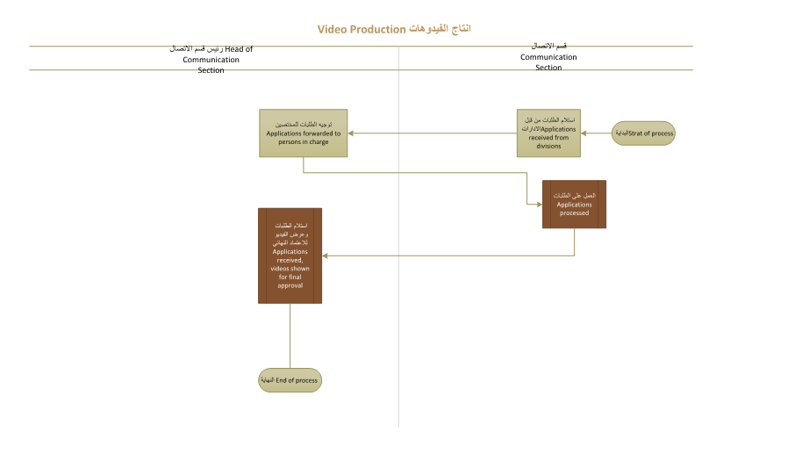

#### Apperance in General

### Facilities

#### Sport Activity

#### New Regular

#### New Sport Project

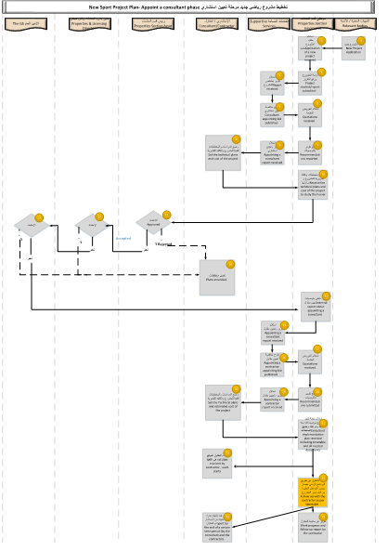

#### New Regular Inspect

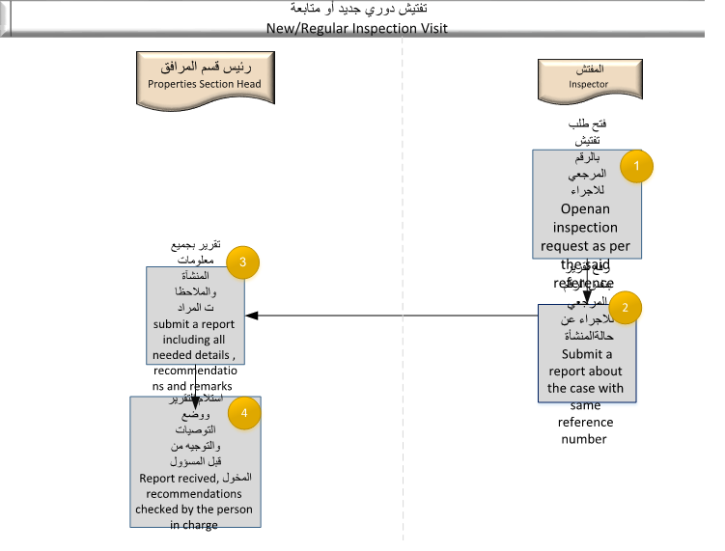

#### Maintenance

### HR Plans

#### Training Allowance

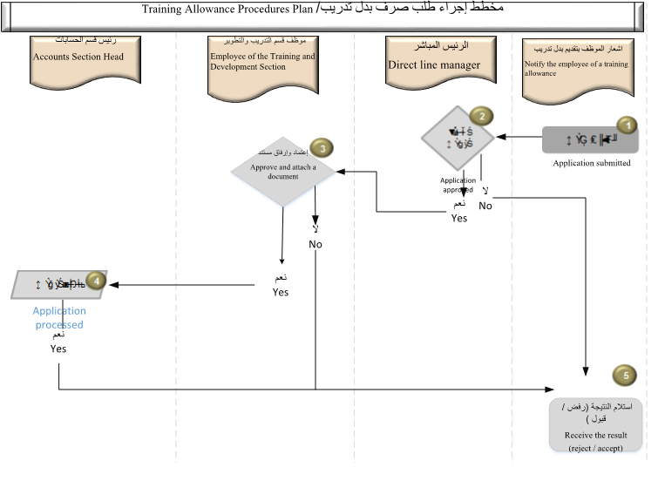

#### Sport Club Service

#### Delegation Job Rotation

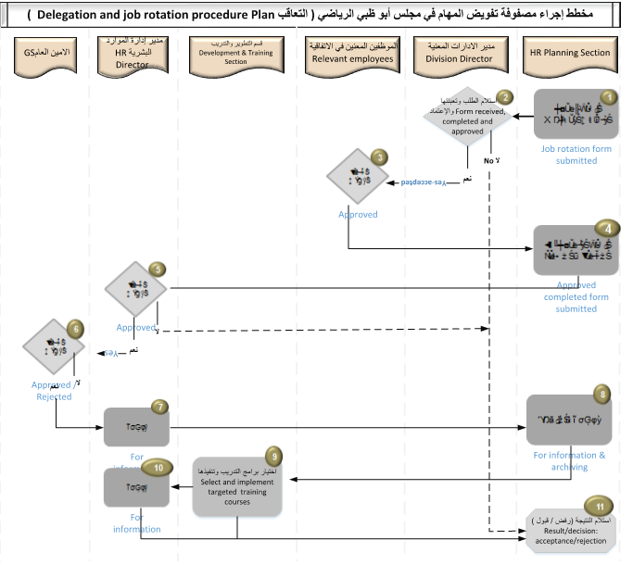

#### Shadow Employee

#### Job Rotation Form

#### Shadow Employment

#### Job Analysis

#### Employee Transaction

#### Official Mission

#### Study Leave

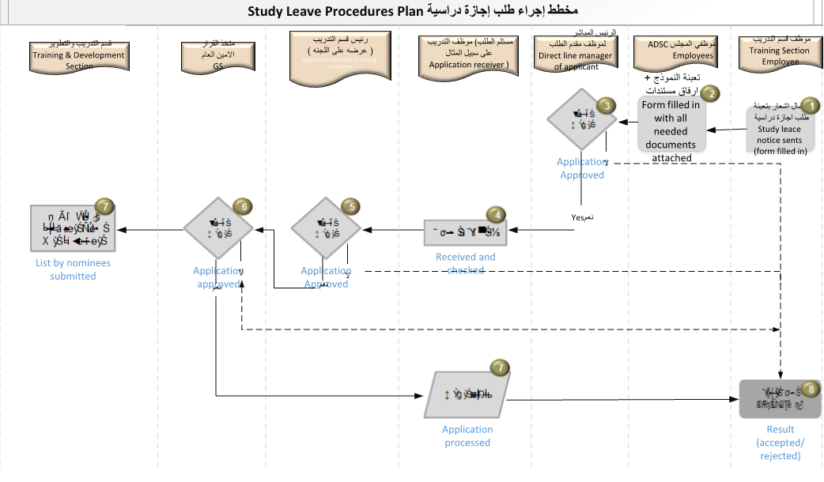

#### Internal Memo

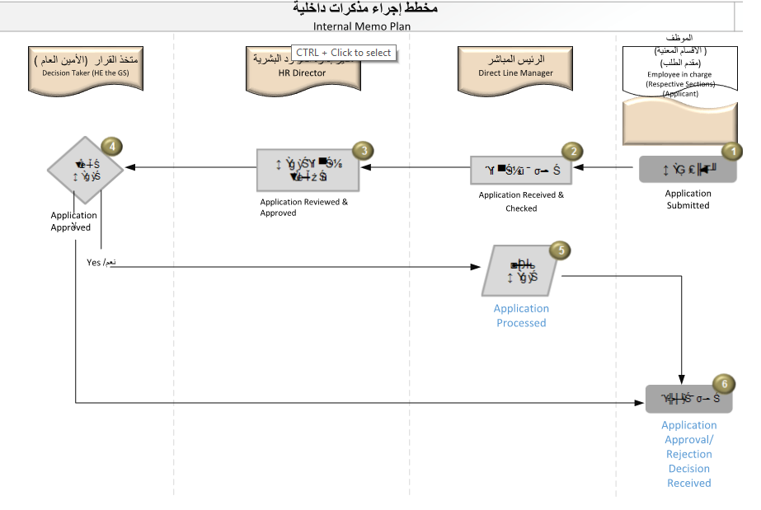

#### Study Leave application

#### Training College

### Technical Affairs

#### Award Procedure Plan

#### Club Financial Support

#### General Regulations

#### Hire and appoint

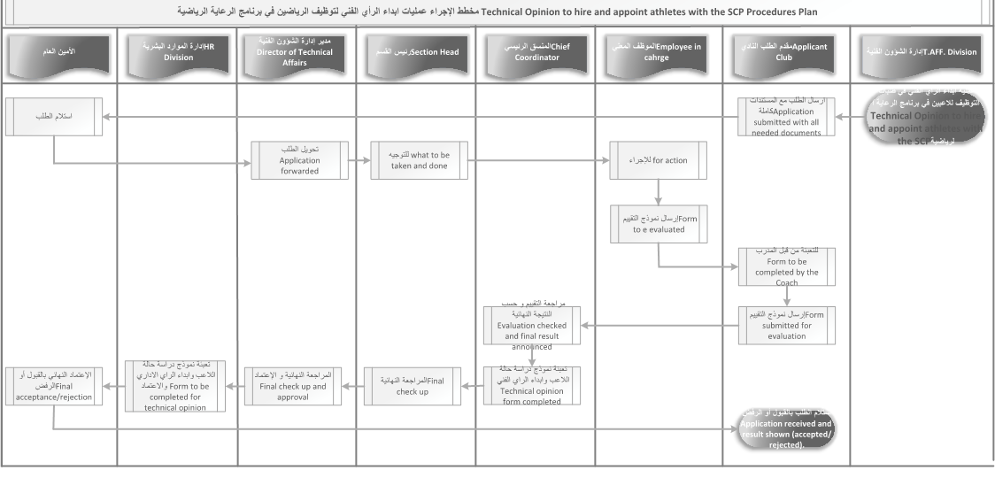

#### Host Sport Even Procedure Plan

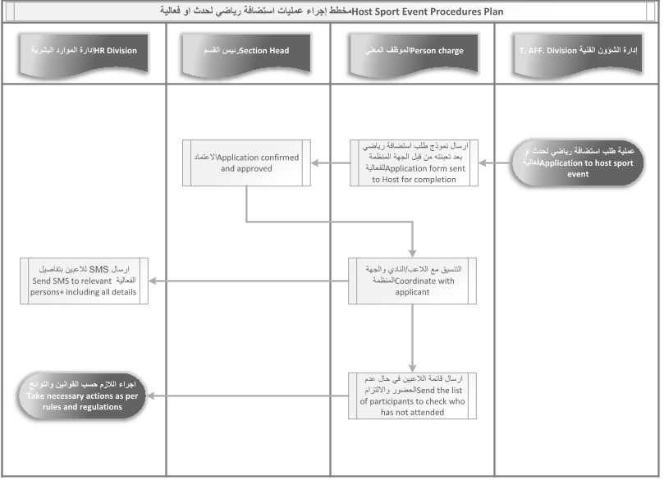

#### Job Support Procedure

#### Training Budget

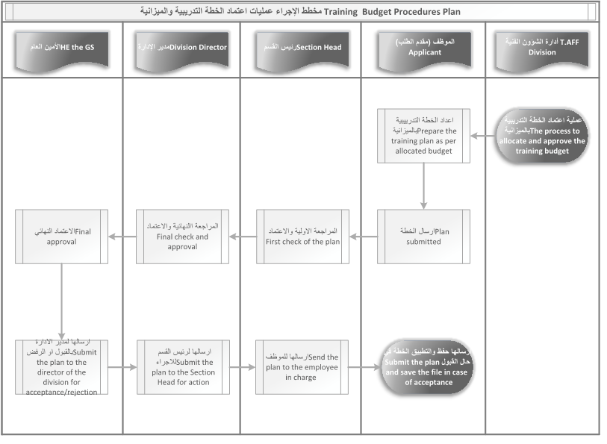

#### Training Course Logistic

#### Training Course Logistic 2A

#### Training Course Logistic 2B

### Events Section

#### Sports Event License

## Proposed Solution Model

**Stand-Alone Fixed Bid**

Verbat will be following a stand–alone fixed bid solution delivery model wherein the required solution would be devised and a suitable pricing would be offered.

## Solution Objective

Verbat Intends to build the application based on the RFP provided by the client. Specifically the following workflows and forms shall be considered as the primary development activity

The system will provide tools for application processing, printing of permits & stickers, fee calculation & collection, and reporting. The salient features of the application to be developed are noted below

### Languages

* English & Arabic

Detailed requirements will be covered in the section titled “Functional Specifications”

Verbat’s Solution architects have conducted a thorough research on the requirements and have come to the conclusion that our proposed solution, which is detailed further in this document, will meet the requirements put forth by the client. And the proposed solution will be delivered in a phased approach as per Verbat’s stand-alone fixed bid solution model.

**Strong and Scalable platform:** The platform proposed will be strong and scalable enough to accommodate future enhancements.

**Accelerated solution:** The framework would act as a solution accelerator. It would provide the basic building blocks which could be reused in future for building new components and features.

**High performance:** The light weight framework used consumes fewer system resources thereby making the application perform faster.

**Security:** The application will be developed considering various aspects of security.

## Advantages of Proposed Solution



01

Agile development offering reliable, secure solution

02

Smooth transition and quicker completion of processes

03

User friendly interfaces enabling easy navigation between screens

## Why Verbat



## Key Differentiators

Delivered digital transformation expertise to global customers for over a decade by following industry best practices to maximize ROI for client

Keen technology intelligence combined with aggressive market research to deliver solutions that achieve results with measurable value

Enable access to global consulting expertise with strong local market and business knowledge

Commercial Model that is customizable for your business needs

Services that are designed to optimize applications for improved performance and overall efficiency

1,000,000 plus man-hours of expertise in technology frameworks spanning Microsoft, Open Source, mobility platforms and other proprietary IT technology

Partners top technology vendors to bring in the latest and best services in integration, collaboration, and development

Commercial Model that is customizable for your business needs

Proven Methodologies & Processes

Investment in R & D

Strong Local Presence

Flexible commercial Models

Technology Associations

Software Development Experience

Offshore Development Centre

Quality Assurance & Testing

## Technology & Services



Technology  
&  
Services

Cloud/Traditional Hosting

User Interface & Design

Digital Marketing

Mobility Solutions

Testing Services

Application  
Development

# Functional Specification

|  |
| --- |
| **ADSC Workflows** |
| **Communication Procedures** |
| Conference Room Application Form (Moderate) |
| Media Coverage Application (Simple) |
| Video Production (Simple) |
| Appearances of General Secretary in Media (Simple) |
| **Events Section** |
| Organize / Host Sporting Championship (Moderate) |
| **Facilities and Licenses** |
| Sport Activity Approval License (Moderate) |
| Inspection Visit: تفتيش دوري جديد أو متابعة (Moderate) |
| New Sport Project plan - Approval of consultant (Complex) |
| New / Regular Inspection Visit:تفتيش دوري جديد أو متابعة (Simple) |
| Maintenance Request (Moderate) |
| **Human Relations** |
| Training Allowance Procedure Plan (Moderate) |
| Sport Club Services Procedure Plan (Moderate) |
| Delegation and job Rotation Procedure Plan(Moderate) |
| Shadow Employee Guidance Form Plan(Moderate) |
| Job Rotation Form Plan(Moderate) |
| Shadow Employment Plan(Moderate) |
| Job Analysis Survey Plan(Moderate) |
| Employees Transactions Finalizing Procedure Plan(Simple) |
| Official Missions Procedure Plan(Moderate) |
| Study Leave Procedures Plan(Moderate) |
| Official Missions Procedure Plan(Moderate) |
| Internal Memo Plan(Moderate) |
| (Moderate) |
| Training Colleges and Universities Procedure Plan(Moderate) |
| **Sport Event License** |
| Sport Event Licensing(Moderate) |
| **Technical Affairs** |
| Training Courses Logistics Support Procedure Plan (Simple) |
| Training Courses Logistics Support Procedure Plan (Moderate) |
| Training Courses Logistics Support Procedure Plan(Moderate) |
| Training Budget Procedures Plan(Moderate) |
| Hire and Appoint Athletes with SCP Procedure Plan(Moderate) |
| Job Support Regulations Update Procedure Plan(Moderate) |
| General Regulations Update Procedure Plan(Moderate) |
| Host Sport Event Procedure Plan(Moderate) |
| Club's Financial Support Procedure Plan(Moderate) |
| Club's Financial Support/Award Procedure Plan(Moderate) |
| **Booking Conference Room Application** |
| **Users** |
| Coordinator of applicant division |
| Director of applicant division |
| Communication Section Coordinator |
| Communication Section Head |
| **Process** |
| Booking form application |
| Application form Approval |
| Submission of Approved Form |
| Application Processing |
| Application form Approval by Communication Head |
| Booking of Conference Room |
| **Media Coverage Application** |
| **Users** |
| Coordinator of applicant division |
| Director of applicant division |
| Communication Section Head |
| **Process** |
| Media Coverage Application form |
| Receiving application form |
| Check, Review and Approval of Application form |
| Reply to Applicant Division |
| **Video Production** |
| **Users** |
| Communication Section |
| Head of Communication Section |
| **Process** |
| Receiving application form from divisions |
| Forwarding application to person in charge |
| Processing Applications |
| Receiving applications and Video show for final approval |
| Appearances of General Secretary on Media |
| **Users** |
| GS office |
| The General Secretary |
| Communication Section |
| communication Section Head |
| **Process** |
| Receiving applications |
| Fixing Appointment dates |
| Informing Communication Section Head |
| Informing Communication Section Head and Instructing about Media appearances |
| Final Approval |
| **Application To Organize/ Host Sporting championship** |
| **Users** |
| The Club |
| The GS Office |
| Events Coordinator |
| Marketing and Communication Director |
| Technical Affairs Director |
| Supportive Service Director |
| **Process** |
| ApplicationForm |
| Receiving Club application form |
| Preparation of memo for necessary actions |
| Decision as per 3 respective directors |
| Application's memo reviewed/remarks and comments added |
| Memo checked /reviewed, comments and remarks added |
| Rejection reasons mentioned in writing/kept |
| Memo after approvals of directors of the 3 respective divisions |
| Memo received and rejection reasons mentioned in writing |
| Final Approval by the H.E the GS |
| **Sport Activity Approval License** |
| **Users** |
| The System |
| Customers |
| Licensing Section Employee |
| Licensing section Head |
| Inspection Section |
| **Process** |
| Properties database 1.Issurance 2.Renewal 3.Amendment 4.Cancellation |
| Enter the application on the system |
| Receive the application, Check the data and documents as per the procedures |
| Transaction approved and forwarded for field action |
| Field action procedures taken to finalize the licensing |
| Approval issued |
| Reasons of rejection received |
| The two transactions to be done simultaneously |
| Application received |
| **New /Regular inspection visit** |
| **Users** |
| Inspector |
| Customer care Section Head |
| **Process** |
| Applicationopened as per reference number |
| Application received |
| Decision |
| Reasons of rejection |
| The two transactions to be done simultaneously |
| Site /Filed visit inspection ,report submitted including supporting pictures, photos and data |
| Report received, recommendations made by person in charge |
| **New Sport Project plan- Appoint a Consultant Phase** |
| **Users** |
| RelevantBodies |
| Properties Section Employees |
| Supportive Services |
| Consultant/Contractor |
| Properties Section Head |
| Properties and Licensing Director |
| The Gs |
| **Process** |
| New Project Application |
| Application of a new project received |
| Project studied/Report submitted |
| Report received |
| Consultant appointing bid submitted |
| Quotation received |
| Recommendations reported |
| Appointing a consultant report received |
| Set the technical plans and cost of the project |
| Receive the technical plans and cost of the project to study them over |
| Approved |
| Step 12 |
| Step 13 |
| Plans amended |
| Report about appointing a consultant |
| Appointing a consultant report received |
| Appointing a contractor appointing bid published |
| Quotations received |
| Recommendations submitted |
| Appointing a contractor report received |
| Set the technical plans and cost of the project |
| Execution /Implementation plan received including timetable and necessary documents |
| Received by contractor, work starts |
| Follow up with the contractor as per the timetable |
| Work progress and follow up report by the contractor |
| Report by the end of a certain time period |
| **New /Regular Inspection Visit** |
| **Users** |
| Inspector |
| Properties Section Head |
| **Process** |
| Open an inspection request as per |
| Submit a report about the case with the same reference number |
| Submit a report including all needed details, recommendations and remarks |
| Report received, Recommendations checked by the person in charge |
| **Maintenance Request** |
| **Users** |
| The Club |
| Properties Section Head |
| Properties Section Employees |
| The inspector |
| **Process** |
| Clubs sends online maintenance request form including all needed documents |
| Report received, property information collected, needed maintenance works detailed |
| Maintenance Request studied |
| Approved |
| Files /site visit as per the case |
| Clun informed and notified |
| Rejected |
| the two transactions to be done simultaneously |
| Prepare a report about the requested maintenance work |
| Report received and achieved |
| **Training Allowance Procedure Plan** |
| **Users** |
| Notify the employee of a training allowance |
| Direct Line Manager |
| Employee of the training and development section |
| Accounts Section Head |
| **Process** |
| Application submitted |
| Application approved |
| Approved and attach a document |
| Application processed |
| Receive the result |
| **Sport Club Service Procedures Plan** |
| **Users** |
| Applicant Club |
| HR Employee |
| HR Section Head |
| HR Director |
| Technical Affairs Director |
| GS |
| **Process** |
| Application submitted |
| Application received and checked |
| Application checked and approved |
| Administrative opinion |
| Technical Opinion |
| Operations taken as per the said case |
| Action taken |
| For approval/rejection |
| Step6 |
| Action taken |
| Acceptance/Rejection |
| **Delegation and Job Rotation Procedure Plan** |
| **Users** |
| HR Planning Section |
| Division director |
| Relevant Employees |
| Development and Training section |
| HR Director |
| GS |
| **Process** |
| Job Rotation form submitted |
| Form received ,approved and completed |
| Approved |
| Approved completed form submitted |
| Approved |
| Approved/Rejected |
| step7 |
| For information and archiving |
| Select and implement target training courses |
| For Information |
| Result/Decision: Acceptance/Rejection |
| **Shadow Employee Guidance Form Plan** |
| **Users** |
| HR Planning Section |
| Training and Development Section |
| Direct Line Manager |
| Relevant Employees |
| HR Director |
| GS |
| **Process** |
| Employee evaluation form submitted |
| Shadow |
| Procedures taken |
| Application form received and approved |
| Shadow Employee Guid's evaluation form submitted |
| Approved form |
| For Approval |
| Approved |
| For information |
| For information and archiving |
| **Jon Rotation Form Plan** |
| **Users** |
| HR Planning and Development section |
| Division Director |
| Development and training section |
| HR Director |
| **Process** |
| Job rotation form |
| Completed form received |
| Completed form received |
| Training courses attended by relevant person |
| Continue filling the form |
| Step6 |
| Step7 |
| Implementation |
| Foe information and archiving |
| **Shadow Employment Plan** |
| **Users** |
| HR Planning Section |
| Division director |
| Relevant Employees |
| Development and Training section |
| Training and Development staff member in charge |
| Direct Line Manager |
| **Process** |
| Shadow employment form submitted |
| For approval |
| Action taken |
| Form received ,approved |
| Form submitted to approve the nominees |
| Application form received and processed |
| Form filling in and completed by relevant shadow employee |
| For approval |
| Result |
| **Jonb analyses Survey plan** |
| **Users** |
| HR Development Section |
| Division director |
| Relevant Section Head |
| Relevant Employees |
| **Process** |
| Job analysis survey form/Application submitted |
| Application form received and transferred |
| Fill the form and approval |
| step 5 |
| step6 |
| step7 |
| step 8 |
| Necessary actions taken |
| **Employees Transactions Finalizing Procedures Plan** |
| **Users** |
| Applicant Club |
| Employee |
| Head |
| **Process** |
| Application submitted |
| Application received and checked |
| Application approved |
| Application processed |
| Result |
| **Official Mission Procedures Plan** |
| **Users** |
| Applicant |
| Respective Director |
| Director |
| HR Section |
| Applicant Direct Line Manager |
| Accounts Section Head |
| **Process** |
| Application submitted |
| Application approved (step3) |
| Application processes, Letter prepared |
| step5 |
| Complete the form |
| Application(step 7) |
| Application received and checked |
| Application processed |
| Result |
| **Study leave Procedure Plan** |
| **Users** |
| Training section employee |
| ADSc employee |
| Direct Line manager of applicant |
| Application receiver |
| GS |
| Training and Development Section |
| **Process** |
| Study leave notice sent |
| Form filled with all needed documents attached |
| Application approved(step3) |
| Received and checked |
| Application approved(step5) |
| Application approved(step6) |
| List by nominees submitted |
| Application processed |
| Result |
| **Official Mission Procedures Plan** |
| **Users** |
| Applicant |
| Relevant Director |
| GS |
| HR Section |
| Direct Line Manager |
| Account Section Head |
| **Process** |
| Application |
| Approved(Step2) |
| Approved(Step3) |
| Decision made |
| Fill the form |
| Approved |
| Approved and checked |
| Application processed |
| Result |
| **Internal Memo Plan** |
| **Users** |
| Employee in charge |
| Direct line Manager |
| HR Director |
| Decision Taker |
| **Process** |
| Application form submitted |
| Form received and checked |
| Application reviewed and approved |
| Application approved |
| Application processed |
| Application approval/Rejection |
| **Training at Colleges and University Procedures Plan** |
| **Users** |
| Training section employee |
| Division director |
| Application received by employee trainee and development section |
| Direct Line Manager |
| Guide employee |
| Application received by HR section |
| IT section |
| **Process** |
| Sent a notification to fill in the form |
| Form filled by relevant divisions |
| Application received and checked |
| Application approved(step4) |
| Application approved(step6) |
| Applicationapproved(step7) |
| Logistics support provided |
| Application processed |
| Application accepted/rejected |
| **Sport Event Licensing** |
| **Users** |
| Applicant |
| Marketing Section Head |
| Marketing Coordinator |
| Tourism and culture department coordinator |
| Marketing and Communication Director |
| **Process** |
| Filling in the license form |
| Application form processed and checked |
| All needed documents and details enclosed |
| Decision |
| Initial approval |
| Application rejected for non-compliance with licensing requirements |
| File kept |
| Final approval |
| Provide all needed documents |
| Inform the applicant about the approval |
| **Training courses Logistics support procedure Plan** |
| **Users** |
| Division |
| Person in charge |
| Section Head |
| Receives the application at the media section |
| **Process** |
| Training room booking process |
| Training room booking completed Request for media coverage |
| Application checked and approved |
| Application received |
| Application Confirmed |
| Response and reply to the applicant |
| Application processed and implemented |
| **Training courses Logistics support procedure Plan** |
| **Users** |
| AFF.Division |
| Letters prepared by |
| Section Head |
| Division director |
| GS |
| Application of club received by |
| **Process** |
| Invitations and form sent out |
| Nomination letters and invitations sent |
| Draft letters checked |
| Final drafts checked |
| Invitations approved and ratified |
| Invitation forward for action |
| Nomination letters and forms sent |
| Nomination form completed by nominee |
| Completed form sent to person in charge |
| Forms sorted out and names of nominees listed to check who is attending |
| **Training courses Logistics support procedure Plan** |
| **Users** |
| AFF.Division |
| Applicant |
| Section Head |
| Receive by statistics section |
| **Process** |
| Analysis survey application+ survey analysis |
| Survey analysis application submitted +all needed documents |
| Application checked and approved |
| Application received |
| Application confirmed |
| Response sent to applicant |
| Survey analyzed+ Final statistical report prepared |
| Final statistical report sent to relevant employee |
| **Training Budget Procedure Plan** |
| **Users** |
| T.AFF Division |
| Applicant |
| Section Head |
| Division Director |
| HE the GS |
| **Process** |
| The process to allocate and approve the traiming budget |
| Prepare the training plan as per the allocated budget |
| Plan submitted |
| First check of the plan |
| Final check and approval |
| Final approval |
| Submit the plan to the director of the division for acceptance /rejection |
| Submit the plan to the section head for action |
| Send the plan to the employee head in charge |
| **Technical opinion to hire and appoint athletes with the SCP procedure plan** |
| **Users** |
| Application submitted with all needed with all needed documents |
| **Step2** |
| Application forwarded |
| What to be taken and done |
| For action |
| Form to be evaluated |
| Form to be completed by the coach |
| Form submitted for evaluation |
| Evaluation checked and final result announced |
| Technical opinion form completed |
| Final checkup |
| Final checkup and approval |
| Form to be completed for technical opinion |
| Final acceptance /rejection |
| Application received and result shown |
| **Job Support Regulations update Procedure plan** |
| **Users** |
| T.AFF Division |
| Person in charge |
| HR Division |
| Section Head |
| Division Director |
| Planning office |
| The GS |
| **Process** |
| Support regulation process |
| Update database of SCP Affiliates |
| Database submitted |
| Analyzed, status quo report prepared |
| **F**irst draft prepared |
| Draft reviewed, Checked and technical suggestions and recommendations made |
| Final technical checkup |
| Draft checked and recommendations made |
| Final checkup |
| Final checkup |
| For action and to keep the file |
| File to be kept |
| File kept |
| **General Regulations Update Procedure Plan** |
| **Users** |
| T.AFF.Division |
| Charge |
| Head |
| Director |
| Strategic Planning office |
| The GS |
| **Process** |
| Regulations and evidence update |
| First draft prepared |
| First draft checked |
| Final checkup |
| Final approval |
| For action and file keeping |
| File to be kept |
| File kept |
| **Host Sport Event Procedure Plans** |
| **Users** |
| T.AFF.Division |
| Personal Charge |
| Section Head |
| HR Division |
| **Process** |
| Application to host sport event |
| Application form sent to host for completion |
| Application confirmed and approved |
| Coordinate with applicant |
| Sent SMS to relevant persons including details |
| Sent the list of participants to check who has not attended |
| Take necessary actions as per rules and regulations |
| **Clubs Financial Support Procedures Plan** |
| **Users** |
| T.AFF Division |
| Applicant Club |
| Employee In Charge |
| Section Head |
| Director |
| **Process** |
| Support process procedures |
| Application submitted with all needed documents |
| Application received |
| Application forwarded |
| For action |
| Step 6 |
| Coordinate with applicant club |
| Support form completed |
| Approved application submitted |
| Application first check |
| Final check of the application |
| Final check and approval |
| Application accepted/rejected |
| Decision |
| Application forwarded for action |
| File kept |
| File kept and club notified of acceptance/rejection |
| For knowledge |
| **Club's Financial Support/Award Procedure Plan** |
| Users |
| Technical Affairs Division |
| Applicant |
| Employee In Charge |
| Section Head |
| Technical Affairs Director |
| Supportive Services division |
| User6 |
| Process |
| Financial award process |
| Application submitted with all needed documents included |
| Application received |
| Application processed and forwarded |
| Action |
| For action as per the regulations of winning international accolades |
| Coordinate with the club |
| Application completed and processed |
| Approved application submitted |
| First checkup |
| First checkup |
| Checkup and approval |
| Final acceptance /rejection decision |
| Decision |
| Application forwarded for action |
| File kept |
| Club informed and notified about acceptance/rejection of their application and file kept |
| FI and knowledge |
| **System features** |
| Authentication & authorization |
| Auditing & logging |
| Exception handling |
| Manage files and folders |
| LDAP Integration |
| SMS & Email |
| ERP integration for PRO requests |
| Scheduling |
| Payment Gateway Integration |
| Invoice Generation |
| English and Arabic |
| Office 365 integration for email communication |
| Application hosting model as cloud or on-premise |
| Reports |

# High Level Design

## Use case Diagrams

### Commuication Procedure

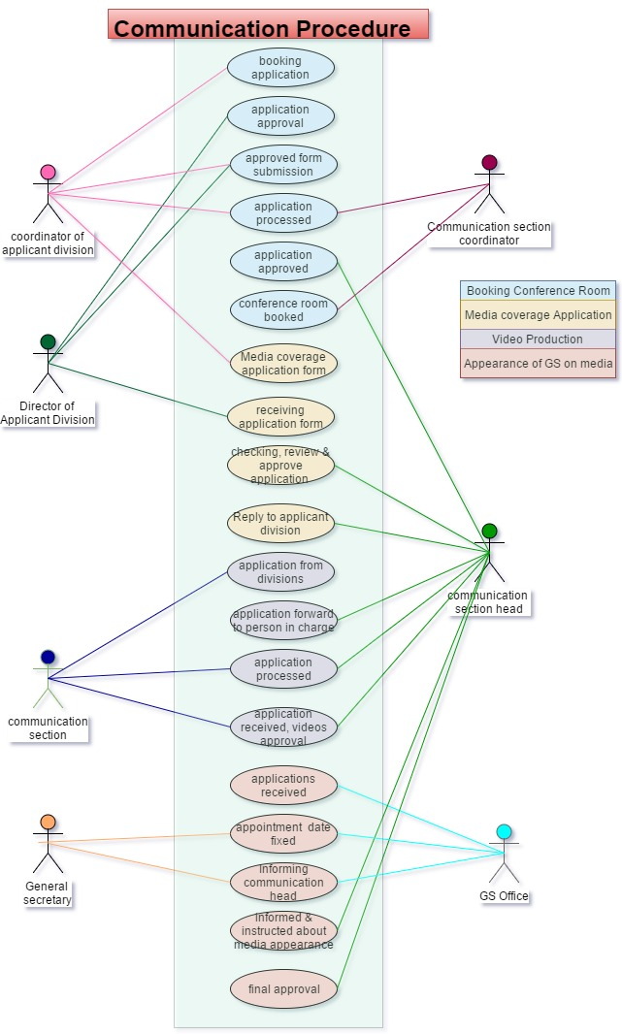

### Event Section

### Facilities and licenses –A

### Facilities &: Licenses – B

## High Level Architecture

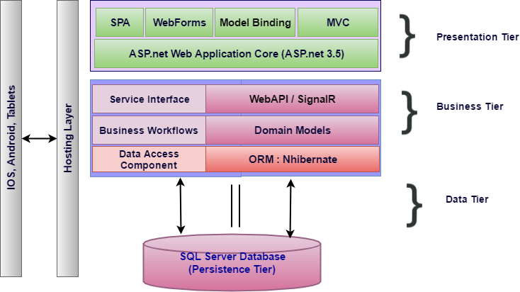

Figure High Level Technical Architecture

The proposed architecture combines the classic MVC architecture along with elements drawn from Service Oriented Architecture (SOA). SOA compliments the requirement where the client’s needs to extend the functionality of the application by retrofitting add-on services in the future.

The business layer represented in the figure above is a service layer that is modelled by the business domain. Hence it becomes easy to contain and isolate workflows. Each service layer results from the culmination of a broad range of granular micro services that work in concert to deliver the desired functionality. If there is a future need for adding new services, this can easily be accommodated by building a parallel pipeline.

Traditionally front end design of .net based applications are done using ASP.net web forms or web pages, but now a days most web applications take advantage of Single Page Applications (SPA) like Angular, a framework that loads a single HTML page and dynamically updates the page as the user interacts with the app. SPAs use AJAX and HTML5 to create fluid and responsive Web apps, without constant page reloads. This is particularly useful, since one of the requirements for the application is a state-full page that supports persistence.

MSSQL is preferred relational database, as per the client. For Rapid Application Development (RAD), most application frameworks employ Object Relational Mappers (ORM). .Net supports both nHibernate as well as Entity framework, both of which are ORM’s. ORM’s support rapid application development by side stepping the work related to managing the intricacies of a relational database. ORM’s also make the application agnostic to database technologies (Such as Oracle, MySql, MSsql etc.).

In order to support portable devices that needs to communicate with the application, Web API’s are implemented and are exposed using restful web services. To enhance and enrich the mobile experience Web services are clubbed with SignalR, a library that simplifies the process of adding real-time web functionality to applications. Real-time web functionality is the ability to have server code push content to connected clients instantly as it becomes available, rather than having the server wait for a client to request new data. This would be of great importance as it will push the latest updates to the handheld devices operated by Inspectors. By doing so the devices could be used both on-line and off-line (Where cell phone reception is bad)

# Nonfunctional Requirement (Others)

|  |  |
| --- | --- |
| **Requirement** | **Details** |
| User Experience and  UI Design | * The application will be developed only in English and Arabic * The layout and graphical components will be created considering the usability factors |
| Performance | * Application will allow users to have smooth and quick access to the information or services they require. |
| Security | * The system will be protected against attempts of security breaching that may arise. * Web security standards will be followed. |

# Assumptions

The project solution and technology is created from the initial understanding of the requirement shared with Verbat through mails and meetings. The proposed solution is based on the following assumptions:

* Client to provide Verbat with the branding guidelines.
* The proposed application front end and backend would be in English
* Client will purchase the necessary templates needed for development
* Client shall provide licensed images and logos in specified size & format
* Super Admin can manage all the users within the application.
* Requirements should be well defined, agreed and signed-off by the client
* Internet connectivity is required for the functioning of the web application.
* Customer will procure templates, SSL certificates & Payment processor
* UI development effort is 2-4 hrs. per screen
* Reporting and analytics may require external tools. Current assumption is that analytics will be minimal and simple.
* Testing will be done in latest versions of Google Chrome, Mozilla Firefox & IE web browsers only
* Development Contingent upon timely feedback from client
* Print formats for stickers and permits will be provided by the client and printing will be done on blank paper sheets (Not printed paper)
* User manuals in Arabic shall not be provided by Verbat
* Client will provide relevant information regarding Integration with external systems like Tahseel, Zajel etc. (to Verbat’ s satisfaction)
* SMS and Email gateways shall be provided by the client
* Client shall provide detailed information regarding Integration with hotel statistics system
* The RFP clearly states that it does not cover all of the details needed for the service provider to make an accurate estimation. The estimate provided is with reference to the information provided by the client. If Verbat finds during the requirement gathering phase that the estimate it provided is grossly misrepresented, it shall exercise rights to renege on the contract

# Out of Scope

With the ever evolving digital market, the requirement needs should be clear to both the parties involved, hence the importance of mentioning the out of scope details of the project. Following are considered to be out of scope while creating this proposal.

* Purchase of images, fonts
* Adding new features to the application other than mentioned in the functional specification.
* Any language other than English
* Manual data entry
* Hardware Integrations / procurement and purchase
* Database migration
* Content writing
* Content or image procurement or uploading or editing.
* Hosting Infrastructure and Maintenance
* Annual Maintenance of the application (Bug fixing, debugging) - For AMC details, please refer section titled “Maintenance and Support”
* Physical deployment at client’s site
* Backup solution and Disaster recovery

# Technology Solution

## Proposed System Environment



IIS..Net 4.5  
MSSQL

MVC / C# / XCODE

HTML / CSS3

**MS SQL2012  
Windows 8/10  
Web Services**

## Technical Configurations

### Development Tools

* Visual Studio, MVC, C#, XCODE, Objective C
* MSSQL
* HTML / CSS 3
* Ajax, JavaScript, JQuery

### Recommended Web Hosting Package

* Medium CPU power – single to dual CPU
* Single Domain
* Windows Sever 2012R2 Data Center
* Disk Space: 5 GB
* Monthly Bandwidth: 10 GB
* Web site Server Software – IIS 8.0

### Browser Compatibility

* Chrome version: 56
* Firefox version: 51
* Edge version: 39

### Hardware Interface

**Desktop**

The application is reliant on hardware interfaces to provide a seamless automated user experience.

* Computer with Windows 8 or 10 OS
* Compatible Browsers as specified in section 7.2.3

# Commercials

## Web Application

|  |  |  |
| --- | --- | --- |
| **No** | **Description** | **Amount (USD)** |
| 01. |  | 00,000.00 |
| 02. |  | 00,000.00 |
|  |  |  |

*Note:*

* *The above cost does not include Application hosting, integration, Project Management or deployment*
* *For change management cost, please refer to section 10 titled Change Management*

## Payment Terms

* Payment terms
* Payment terms
* Payment terms

*Note: Payment should be made within 7 days from the date of the invoice*

## Mode of Payment

By Cheque / DD to Verbanet Technologies LLC

OR

Wire transfer to our bank account

Bank Name : Emirates NBD

Account Name : Verbanet Technologies LLC

Account Number : 1011492858201

IBAN Number : AE61 0260 0010 1149 2858 201

Swift Code : EBILAEAD

Bank Address : Mamzar Branch, Dubai

*Note: Bank charges incurred during wire transfer to be borne by the client. Any local taxes applicable to be borne by the client*

# Delivery Management

## Project Management

The Verbat development center strictly follows industry standards on quality. The project management is process governed by the Verbat Quality Management system and is put to verification through internal audit programs that happen from time to time.

Verbat will dedicate a project manager for the proposed implementation. Verbat proposes Client to identify one project manager who will be driving activities to be undertaken by Client to be the single point of contact for Verbat.

## Roles and Responsibilities

Verbat will assign a dedicated Project Manager/Project Lead to lead the project, who will be the first point contact for Client. He/she will be responsible for planning and managing the various activities within the project. He/she will work closely with Client Project Manager, to give periodic status updates and ensure high level of visibility and comfort on the progress of the project.

The Project Manager/Project Lead will lead the co-ordination between Verbat and Client, thus enabling smooth transitioning of Client requirements to the Verbat’s offshore delivery team, and provide visibility as well as comfort on the progress of the services to Client.

He/she will have periodic meetings with Verbat’s Senior Management, thus ensuring Verbat’s Management commitment and focus on Client initiatives.

## Delivery Activity Summary

|  |  |
| --- | --- |
| Activities | Description |
| Detailed requirement Analysis | Verbat team to conduct detailed study of requirement for the phase. If clarification is required, team will reach out to Client for more information and/or time for discussions. |
| DB Design | DB design for central and test DB. |
| Software Requirement Specification document (SRS) | Once the requirement analysis is completed, Verbat team will submit the SRS document for approval |
| UI/UX Design, Prototyping | Based on the SRS, Verbat UX/UI team will work on the UI/UX of the screens and submit a prototype for approval |
| Functional Specification Document (FS) | Once the Prototype. UI/UX is approved, Verbat shall submit an FS document for approval. |
| Development | Actual system development starts based on the FS. This involves detailed design and software development of Web Application. |
| Testing | Test Planning, test plan creations, internal, integration testing and user acceptance testing. |
| Deployment | Deploying the latest built in the Verbat Test Server. |

## Project Implementation Plan

Verbat will be providing the solution in a stand-alone fixed bid approach which ensures minimum viable solution for quick wins with core focus on the long-term business objective and outcome. Once the implementation is over, Verbat will initiate the application maintenance process (once the maintenance contract is signed) which continues to extend after the implementation.

## Deliverables

|  |  |  |  |
| --- | --- | --- | --- |
| No | Deliverable | Description | Timeline |
| 1 | Weekly updates | A weekly update email/report shall be sent to project team in SCTDA to update them with the status of the Solution | Weekly |
| 2 | Solution User Guides | Comprehensive end user guide and technical documentation in English language for both types of users end (hotels) and admin (SCTDA) | Upon Project completion |
| 3 | LCS Solution | The full functioning Solution with the above mentioned requirements | Due Date |
| 4 | Source Code | Fully functioning source code of the Solution, Database, Inspection iOS app, and reporting with all licensing and keys. The source code must be editable completely by any third party without the need to refer to the Consultant, along with its technical documentation | Upon Project completion |
| 5 | Training workshop | Organize and provide training to the different users of the Solution | Upon Project completion |

## Estimated Delivery Time

**UAE working days for prototype from the date of Approval of the project (LPO/Signed proposal) with advance payment: 15 working man days**

**UAE Working days for the development of the application from the Date of Approval of the Prototype: 7.5 working man months**

| **Activity** | **Deliverables** | **Timeline** |
| --- | --- | --- |
| Project Initiation | Scope Document, Project plan |  |
| SRS | System Analysis & User Specification, Updated project plan, prototype |  |
| Prototype  (parallel stream ) | Working prototype |  |
| Development | Working Application |  |
| Testing | Testing scenarios |  |
| Deployment | Tested Web, Tablet & Mobile  Application in IOS, Source Code |  |

## Deployment Details (at Clients Behest)

* Client can opt for hosting the application at Verbat’s Server.
* If deployment is at the client’s server, responsibility of deploying the application onto the production environment after conducting the necessary acceptance testing will lie with the client unless and until Verbat’s support is contracted for deployment.

***Note****: Hosting the application at Verbat’s server will call in for additional charges.*

## Release Planning

* Client will be informed about the release date and time through email.
* Client performs the UAT

## Risk and Contingency Planning

Verbat has identified various risk factors associated with this assignment and understands the impact of these risk factors on the project schedules. The objective of this section is to highlight for both Verbat and client, the risk factors, to analyze the impact of the risks on project execution, and to propose strategies to control and reduce the impact of the risk factor.

These various risks, which could arise during the project, are tabulated below along with mitigation implementation.

| Type of risk | Impact | Risk Mitigation | Risk Handling |
| --- | --- | --- | --- |
| Scope Creep | H | Functions and features will be detailed in system requirement documents and will go through client approval. Once this document is approved, any change to requirement will go through change management review for possible impact assessment. | Proper change management procedure will be implemented. |
| Delay in customer feedback | H | The plan is prepared with enough lead-time for customer reviews and approvals.  The customer is indicated with the dates when the document is expected after review and approval. | The request for feedback will be escalated if not attended at the right time so that the schedules are not affected. Deemed acceptance criterion is set up front and will be followed. |
| Non-availability of necessary software’s, frameworks, database instances and infrastructure at client’s hosting environment(If hosting support is provided by Verbat) | M | Client will be informed in advance on these requirements. | Possible impact to schedule. |
| Manpower attrition | L | All efforts would be made to ensure process dependence rather than being person dependent. As a risk mitigation plan Verbat will train backups. | A new person will be identified as early as possible, provided the required project-specific training and mentored by the senior members of the team to minimise impact of attrition on the project. |

*H-High, M-Medium, L-Low, NA-Not Applicable*

# Change Management

Any addition which comes out of the project scope, upon and after the launch of the tool will be considered as change management. Verbat recommends the following change management procedure for the same.

* Any change which comes out of the project scope, which was discussed, documented, and mutually approved by both the parties in the requirement stage, will be carried out only through raising a change request.
* Change request will be studied and an impact analysis on the existing work flow will be performed.
* On finalizing the impact, effort estimation for the change will be calculated and raised as additional requirement.
* Verbat will initiate the change request only after getting a formal approval from the client for the additional changes raised.
* Any change from the scope will be charged at **USD ----- per man day effort** and approval from the clients will be availed before commencing on any change management.

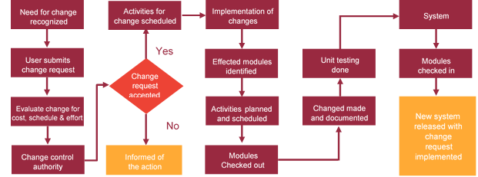

# Miscellaneous

## Acceptance Criteria

* UAT sign off should happen within 7 Days from the release of the application/ Phase and the acceptance confirmation needs to be mailed to Verbat failing which Verbat will consider the project as approved by the client.
* Any comments or reason for rejection need to be documented and the same needs to be sent as an email from the official mail id of client to Verbat.

## General Terms and Conditions

* An average of 20 working days are assumed in a month
* All the projects activities will be carried out from our off-shore development center in India
* The scope of the project is to develop the Application as detailed in the scope of the project and mentioned in this proposal. Any changes or additions will have to go through change management.
* This proposal and all technical/ functional specifications have been derived or concluded from the data shared via email / information's transferred during the initial requirement analysis meetings and conversations. Verbat reserves the right to amend the terms of this proposal, should the SOW terms, functional features and functionalities change during the course of the project
* Application will be best viewed only in the environment mentioned in the section 7.2.3
* All the documentation will be provided in English.
* Third party components may be used to develop this application.
* All Source Code and other project artefacts would adhere to the Verbat document templates and internal coding standards
* Acceptance criteria shall be based on the clauses which were mutually discussed between Verbat and client at the Requirement Analysis phase and the same will be documented and approved by both parties through official emails
* In case Client requires any extension of the proposed acceptance schedule, the associated effort and cost of such extension can be mutually reviewed.
* For any circumstances if project needs to be put on Hold / Stop it requires minimum request notice period of 1 week along with duration for which request will be addressed by management and final decision on the request will be based on that
* If deployment is done in client’s server, Verbat cannot be held responsible for any performance issues arising due to hardware malfunctions.
* Client is responsible for data backup in case the application is not hosted on Verbat server.
* Source code will only be delivered or uploaded on the Production Server once the due payments are made.

## Assumptions and Dependencies

* Detailed system study is required before the start of the project.
* During the requirement gathering phase, authorized personnel from the Client’s side is expected to be available for discussion and finalizing the HLD (High Level Design), before development commences.
* Type of reports and formats, if under the scope of the project, needs to be specified by Client before project sign off.
* Workflows if under the scope of the project, need to be specified/ confirmed by client before project signoff.
* All queries regarding the client requirement and any queries which may hinder the project advancement at any stage should be answered by the client within 24 hours from the time of initiation, failing which the time delay will get added to the actual effort which was estimated.
* Verbat assumes that all sign-offs from Client will be provided within agreed and specified timeframe.
* Client will provide all the necessary contents, both text and image, before starting the project in the format suggested by Verbat (if any).
* The client should provide the relevant information and data well in time for the execution of a related activity. Non- availability of this information or data may lead to an interruption of work which may result in a delay in delivery as well as additional costs to the client.
* Client should have/possess server with technical specifications as suggested by Verbat for the proposed application.

## Source Code & Intellectual Property Rights

* Upon completion of the Project and 100% completion of the payment, client will have access to the source code except for propriety codes, developer tools and third party application etc.
* The solution offered will be the intellectual property of the client and will be made available to the client on an “unlimited license” basis.
* Modifications by third party/person: No person or organization, other than Verbat or any person authorized by Verbat in writing, has any permission to modify/change the software Solution to be eligible to get continued support from Verbat as per the support terms defined under this document.
* Liabilities/Damages: Verbat accepts no liability or damages of any kind arising out of use or non-use of the software delivered. The responsibility of testing of software lies with Client.

## Maintenance & Support

* Maintenance contracts by default are supported as per the basic SLA terms.
* **AMC with Basic SLA is charged at 20 % of the total project value**. Additional Effort/change management request will be added towards Total Value of the Project to determine the AMC value.
* Maintenance support is limited to providing application support for ensuring the consistency of the look-and-feel, bug fixes and user issues i.e. maintenance and support of the existing features of the application.
* Support does not in any way cover providing technical or other support to the end users. The maintenance agreement does not include functionality changes or feature additions which are handled as change requests which will be charged AED 1200 per man day. AMC does not include server support, maintenance and application deployment.
* AMC charges will cover Off-Site Support and Debugging. Support includes E-mail, Telephone and Chat unless explicitly specified. In the event, the application is hosted with the client; necessary remote desktop connectivity should be provided for carrying out maintenance activity.
* Gap in AMC - In case if the client does not opt an AMC for a year and want to renew it after that period, 50% of the AMC amount for the year for which AMC is not taken will also be payable if the client wishes to renew the AMC contract.
* Note:
  + Please note that the AMC support shall start only after all the necessary sign-offs (AMC Document) to this effect have been given.
  + It is not mandatory that the client should opt for an AMC. The client will still be supported on an ad-hoc basis on an agreed man-day rate.
  + AMC Payment Terms: 100% to be paid as advance.

## Service Level Agreement

|  |  |  |  |  |
| --- | --- | --- | --- | --- |
| **Key** | **Max Response Time** | | **Max Resolution Time** | **Target** |
| Basic | 1  working day | 3 working days | | Request / incident / problem tickets |
| Advanced | 5 Business Hours | 12 Business Hours | | Request / incident / problem tickets |
| Priority | 3 Business Hours | 5 Business Hours | | Request / incident / problem tickets |

Note:-

* We provide Basic SLA as standard with AMC while Advanced and Priority SLAs attract additional charges.
* Time zone applicable as per India time zones (3:30 AM GMT to 12:30 PM GMT- Monday to Friday).

# Our Clients

**UAE University**

Education

Transportation

**Canada Cartage**

Construction

Services

Finance

We look forward to hearing from you soon and hope that you will give us the privilege to work with you in meeting your business goals. Thank you.

Thank You



©   
1999 - 2017. All Rights Reserved   
Verbanet Technologies LLC  
www.verbat.com